MATLAB-Based Project: Attenuation of Power-Line Interference in EMG Recordings

Project Rules:
Unlike our weekly problem assignments, you must complete this project yourself, without the help of other students in this course. You may consult with the course instructor. You may also consult with persons who are not enrolled in this class, so long as those people are not used to pass information indirectly between students, and so long as you list these interactions on your project report. You must write all of the MATLAB functions yourself. You must originate the report writing yourself, but are welcome to get writing critique/proof reading from others (again, from people who are not currently enrolled in the course).
Please provide a hard copy of your report on the due date and e-mail an electronic copy (.doc or .docx format preferred) by the due date. Name the electronic copy using a last name-first name format, with all lower case letters, using an underscore character between names. For example, my file name would be “clancy_edward.doc”.
Projects will be graded using the standard academic letter scale, with an “A” corresponding numerically to a 95/100, “B” to 85, “C” to 75, “D” to 65, “F” to 50 and incomplete/omitted to 0. All writing should be in complete sentences and formal grammar, as quality of writing will contribute to the overall grade. Caption all plots, label all plot axes, etc.

The Context (well, an example context, since this problem occurs in many settings…):
In many bioelectric monitoring applications an important signal processing challenge is that of removing (well, attenuating is more realistic) power-line interference from recorded signals. We will consider the problem for recording of skeletal EMG (electromyogram — the electrical activity of skeletal muscle), although this precise application is only a convenient example. Conventional surface recording of EMG provides a signal that looks very much like an amplitude-modulated Gaussian (random) process with a pass band between about 20–400 Hz and a RMS amplitude of a few mV. A 5 s segment of a sample EMG signal is shown below. (The green trace is an example EMG signal. My apologies that this plot is such a poor resolution trace with no axis labels — it was easy and quick to locate.)
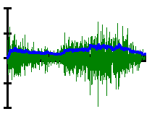
Time
Voltage
A rough sketch of the pass band (power as a function of frequency) is given below.
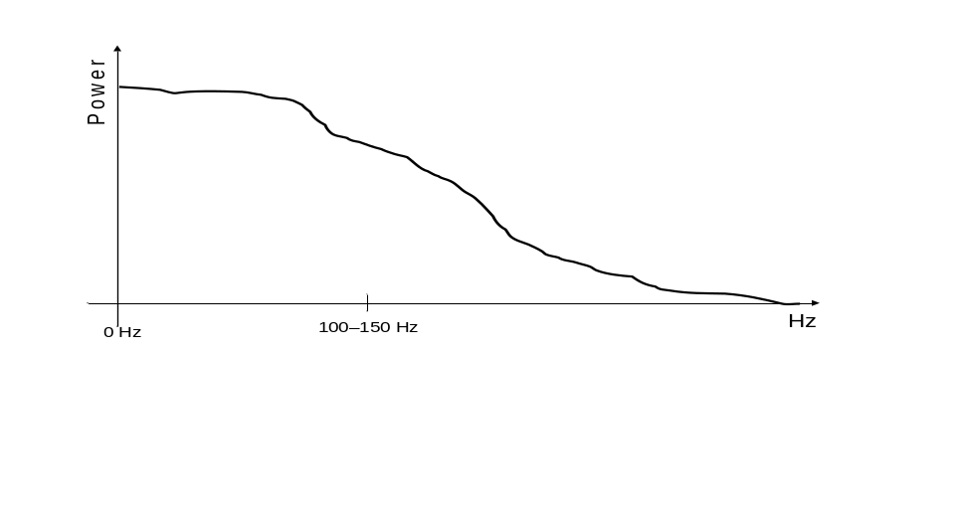
We are going to concentrate on issues related to interference due to the power line fundamental frequency at 60 Hz (50 Hz in some countries). Note that the power line frequency lies well within the signal frequencies of EMG. Also note that you really will not need to know much about EMG to complete this mini-project. (I narrated the above description to provide some context to the signal processing problem.)
I want you to consider pre-recorded EMG signals, a.k.a. signal epochs. Epoch durations may be as short as 20–40 ms and as long as several minutes. Surface EMG is commonly sampled digitally at a rate of 2000–4000 Hz. (Most of the signal power is below 400 Hz, but there is actually some usable power out to about 1–2 kHz.) And, consider pre-recorded EMG signals that have some undesired level of 60 Hz interference superimposed. The goal is to remove as much of the 60 Hz interference as possible from the discrete signal epoch, with minimal alteration of the “true” EMG signal. For this mini-project, ignore continuous-time power line harmonics and just concentrate on the 60 Hz component. Assume that the ADC resolution is not really an issue (i.e., assume infinite ADC resolution for this discussion).

Overview of the Project:
In this mini-project, I will ask you first to design a small suite of MATLAB functions that (i) simulate an EMG signal (with power line interference) (ii) filter the simulated EMG signal to attempt to remove 60 Hz interference (two functions) and (iii) evaluate the performance of a 60 Hz filter . You will then be asked to execute some simulations and discuss/analyze the relative merits of the interference removal methods. A structured report format (described below) will be used to communicate your work for grading. You must use the structured format to hand in your work.
The remainder of this assignment write-up describes, step-by-step, your expected project work and project report. In general, you should be able to move through this write-up in a sequential fashion, completing each portion of the MATLAB-analysis-project report as you go along.

Required MATLAB Functions:
There are four MATLAB functions that you will be required to create. Of course, you may also elect to write other functions as part of the analysis portion of the project. But, these four functions are required. Write the four based on the descriptions given next. Assume a sampling rate of 2048 Hz throughout the project. Use the function names that I assign below for these four functions.
- MATLAB function “emg_sim()”: Write a MATLAB function that simulates an EMG signal that has been sampled at 2048 Hz. An input to the function should be the simulation duration, in seconds. A second input should be used to assign the magnitude of the power line interference relative to the RMS value of the “clean” EMG signal. One output from the function should be the simulated EMG vector, prior to the inclusion of 60 Hz interference (see below). Another output from the function should be the simulated EMG vector, including the 60 Hz interference. You may utilize additional arguments if you choose. To simulate an EMG signal, first use MATLAB function “randn()” to create an independent, zero-mean, Gaussian random vector. Be sure to use the system clock to randomly state (a.k.a. “seed”/”state”) the randn() generator before using it. [See the MATLAB help page for randn(), or issue the command “randn(‘state’, sum(100*clock));”. Note that the newest versions of MATLAB state the random number generator with a new syntax — but still accept the old syntax.] Second, design a second-order low pass Butterworth filter with cut-off frequency at 150 Hz. Third, pass the random sequence through the Butterworth filter. Doing so shapes the random sequence so that it looks like a constant-effort EMG signal with a spectrum similar to the figure shown above. Fourth, add an appropriately-scaled 60 Hz sine wave to the signal (to simulate power line interference). Fifth, note that the Butterworth filter will have a start-up transient associated with it. This transient degrades the fidelity of the simulation. Thus, your initial random sequence created by randn() must have a length equal to the desired EMG sequence length plus the length of the start-up transient. In step five, “chop off” the start-up transient from the stage four sequence. Your simulation is complete. Note that the absolute scaling of the EMG signal is not important to this problem. Only the relative amplitude of the EMG signal with respect to the 60 Hz interference. Because the EMG signal is random, it is usually best to scale the amplitude of the 60 Hz interference to the RMS value of the simulated “clean” EMG (after low pass filtering).
- MATLAB function “emg_notch60()”: Write a MATLAB function that “notch” filters the EMG signal at 60 Hz, using a zero-phase LTI filter with rational frequency response. A notch filter has a gain of one at all frequencies except in a small neighborhood of frequencies surrounding the notch frequency. An input to your function should be the input EMG signal. Another input should be the order of the notch filter. An output to your function should be the resulting notch filtered EMG signal. You may utilize additional arguments if you choose. You are free to select any IIR or FIR filter design method that we have discussed in the course (or any method that is similar to any of these methods). I recommend that you use the MATLAB design functions available to you [e.g., fir1() or butter() or firpm() or …]. Note that the filter order should influence the performance of the interference attenuation. Be sure that your filter implementation is zero phase.
- MATLAB function “emg_freq_null()”: Write a MATLAB function that nulls the DFT of the EMG sequence in the neighborhood of 60 Hz, as described subsequently. An input to your function should be the input EMG signal, denoted x[n] in this description. An output to your function should be the resulting notch filtered EMG signal, denoted y[n] in this description. You may utilize additional arguments if you choose. Let x[n] be of length N. Compute X[k], the N-length DFT of x[n]. Determine the positive-frequency and negative-frequency locations within X[k] corresponding to 60 Hz (or, as close as possible), denoting these indexes k₁ and k₂. Set Y[k] to zero in a small range of indexes about 60 Hz i.e. 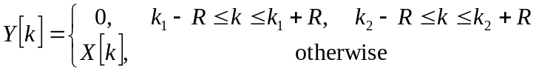, where integer R specifies the range. Form the output sequence y[n] as the inverse DFT of Y[k]. Be sure that you implement this nulling such that y[n] is a real-valued sequence. (Thus, you must preserve symmetry in the frequency domain when nulling the positive-valued frequency and negative-valued frequency ranges.) Also, be sure that the width of the null always represents the same frequency span in Hertz (not the same frequency span in samples), regardless of the signal length. That is, as the length of the sequence grows, more samples must be notched in order to discard the same range of physical frequencies. In the DFT, 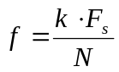, where f is frequency in Hertz along the DFT x-axis, k is the sample index along the DFT x-axis, F_{s} is the sampling frequency in Hertz and N is the length of X[k].
This process essentially creates a frequency-domain filter H[k] whose values are either one (where the original spectrum is preserved) or zero (at the nulling locations). H[k] is multiplied by X[k] to form Y[k]. Hence, the above process is formally circular convolution! Nonetheless, the process is utilized by EMG researchers. Although circular convolution is performed (distorting the signal) no start-up transient is incurred (start-up transients also distort the signal).
- MATLAB function “emg_compare(): This function will be used to evaluate the performance of a “60 Hz” filter. One input to the function should be the simulated EMG “truth” vector, that is, the simulated EMG prior to the inclusion of 60 Hz interference (as generated by the EMG simulator). Another input to the function should be the simulated EMG “test” vector, after it has been filtered through one of the interference filters. Both of these input vectors should be of the same length. An output from the function should be a (scalar) measure of similarity between the “truth” and “test” vectors, such as the RMS error or average absolute difference. The error measure should reflect how closely the “truth” EMG signal matches the “test” EMG signal. The error measure should be invariant to signal length (such as RMS or average absolute difference, which normalize error to the sequence length). You may use additional arguments if you choose.

These four functions form a test suite cascade that will be used to simulate and evaluate the three interference cancellation techniques. The general paradigm is shown below. You will likely benefit from writing additional MATLAB functions that implement this paradigm, using the four functions you have written above, perhaps augmented with other functions.
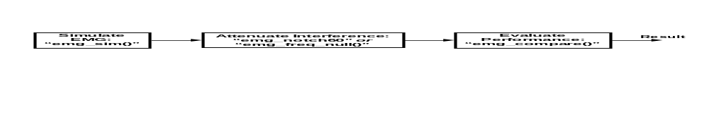

Analysis and Project Report:
All project reports must be typed: minimum font size of 12 points, 1.5 lines spacing, number pages sequentially starting at “1” with the title page.
Your project report should be comprised of the sections described below, in the order specified below. Be sure that all axes of all plots are fully labeled.
- Title Page: Include your name, the course number, the date and the project title.

- 1. Consultations: If you consulted any persons, other than the course staff, about the project, then you must describe your interactions in a “Consultations” section. Starting on a separate page from the Title Page, label a section “1. Consultations.” On this page, describe your consultations. In general, this description should be brief and is meant to (i) acknowledge your interactions with others that contributed to your MATLAB development, analysis and/or writing and (ii) demonstrate that your interactions abided by the project rules. In general, this section should not exceed one page.
If your project did not utilize any consultation of persons (other than the course staff), then still provide this “Consultations” page, entering “None.” for the body of this section.

- Starting on a separate page, label a section “2. Verification of Required Software.” This section will contain the following items, provided in this specified order, which are used to verify the functioning of the required software functions:
  - Starting on the first page in this section, provide the MATLAB software code listing for “emg_sim()”.
  - On one separate page, provide a MATLAB time plot showing a sample output from emg_sim() for a sequence of length equal to one second (top plot) and the DFT magnitude of this sequence (bottom plot). Use MATLAB to label the x-axis of each plot. Also label the y-axis (this axis is usually labeled in “Arbitrary Units,” since we are really not scaling the EMG in physical units).
  - Starting on a separate page, provide the MATLAB software code listing for “emg_notch60()”.
  - On one separate page, show the magnitude response of a notch filter designed by “emg_notch60()” utilizing a low filter order (top plot) and the magnitude response of a notch filter designed by “emg_notch60()” utilizing a high filter order (bottom plot).
  - On one separate page, show the DFT magnitude of a sample, simulated EMG signal corrupted with 60 Hz interference (top plot) and the DFT magnitude after processing this signal through the notch filter emg_notch() (bottom plot). Both plots should be frequency-domain plots.
  - Starting on a separate page, provide the MATLAB software code listing for “emg_freq_null()”.
  - On one separate page, show the DFT magnitude of a sample, simulated EMG signal corrupted with 60 Hz interference (top plot) and the DFT magnitude after processing this signal through the frequency nulling filter emg_freq_null() (bottom plot). Both plots should be frequency-domain plots.
  - Starting on a separate page, provide the MATLAB software code listing for “emg_compare()”.
- Starting on a separate page, label a section “3. Analysis: Notch Filter and its Start-Up Transient.” For this section, you are asked to devise a set of MATLAB simulations to evaluate the performance of the notch filter for removing 60 Hz interference in the simulated EMG. You must determine the methods for these simulations yourself. Your simulation must vary two parameters: the duration of the EMG sequence (minimum range considered must be between 100 ms and 5 s) and the order of the notch filter (minimum range considered must be between 2–10 for IIR filters and 100–1000 for FIR filters). You can select the granularity of the parameters. Note that a zero-phase notch filter will elicit both a “head” and “tail” filter transient. In this section, leave this transient with the filtered EMG signal when you evaluate performance. Conduct an appropriate series of MATLAB simulations to evaluate filter performance versus EMG duration and notch filter order. You must report your results in a graphical form, although you may also report appropriate numerical results. Try to present your graphical results efficiently, for example using a family of two dimensional error curves or a contour plot of errors. Note that your EMG simulator will produce random EMG sequences. Hence, your performance results will have some variability to them. You may wish to evaluate a given duration-order case multiple times, and then report the mean (and perhaps standard deviation) of the performance results.
To report your results, begin by labeling a sub-section “3.1. Methods.” In this sub-section, describe your simulation methods in sufficient detail that someone else could repeat (i.e., “replicate”) them. Next, label a sub-section “3.2 Results.” Present your results in this section. Lastly, label a sub-section “3.3 Discussion.” Discuss your results in this section. For example, compare and contrast performance as a function of sequence duration and/or notch filter order. You are welcome to select to perform additional related simulation work for this scenario.

- Starting on a separate page, label a section “4. Analysis: Notch Filter WITHOUT Start-Up Transient.” For this section, you will evaluate the performance of the notch filter technique, but in situations in which the start-up transient can be discarded. In particular, some EMG epochs are sufficiently long in duration that the start-up transient comprises a relatively short fraction of the total signal duration and can be removed before the EMG sequence is further analyzed. In these cases, we only care about the performance of the 60 Hz filter after the start-up transient has been discarded. For this section, vary the order of the notch filter (minimum range considered must be between 2–10 for IIR filters and 100–1000 for FIR filters) using a granularity of your choosing. Conduct an appropriate series of MATLAB simulations to evaluate filter performance versus notch filter order. Before each performance evaluation, discard the “head” and “tail” filter transients and truncate the signal down to a fixed duration. Use this one duration for every simulation in this section (regardless of the filter order). I would recommend retaining a truncated duration of several seconds. You must report your results in a graphical form, although you may also report appropriate numerical results. Similar to the previous section, report your results in sub-sections labeled “4.1. Methods,” “4.2 Results” and “4.3 Discussion.” You are welcome to select to perform additional related simulation work for this scenario.

- Starting on a separate page, label a section “5. Analysis: Frequency Nulling.” For this section, you are asked to devise a set of MATLAB simulations to evaluate the performance of the frequency nulling filter [emg_freq_null()] for removing 60 Hz interference in the simulated EMG. You must determine the methods for these simulations yourself. Your simulation must vary one parameter: the duration of the EMG sequence (minimum range considered must be between 100 ms and 5 s), using a granularity of your selection. Conduct an appropriate series of MATLAB simulations to evaluate filter performance versus EMG duration. You must report your results in a graphical form, although you may also report appropriate numerical results. Similar to the previous sections, report your results in sub-sections labeled “5.1. Methods,” “5.2 Results” and “5.3 Discussion.” You are welcome to select to perform additional related simulation work for this scenario.

- Starting on a separate page, label a section “6. Discussion and Conclusion.” Write a general discussion and conclusion. The discussion may cover, for example, the relevance and accuracy of the simulation model, study limitations, the relative/comparative merits of the three filtering techniques, ideas for future work, etc.

- Place all of your additional MATLAB functions, if any, in a report appendix.

- If appropriate, provide a References section and/or additional Appendices.

If you wish to evaluate additional methods for attenuating 60 Hz interference, you are welcome to do so. If you do so, insert these analyses just prior to the “Discussion and Conclusion” section, incrementing the section numbers appropriately. In any of the above-specified required sections, you are also welcome to include any other useful parameter variants (e.g., different filter design techniques for the notch filter, different nulling range, etc.). Some flexibility in report format is appropriate if you include such additional work.

